

2025 call for nominations for

employer of the year

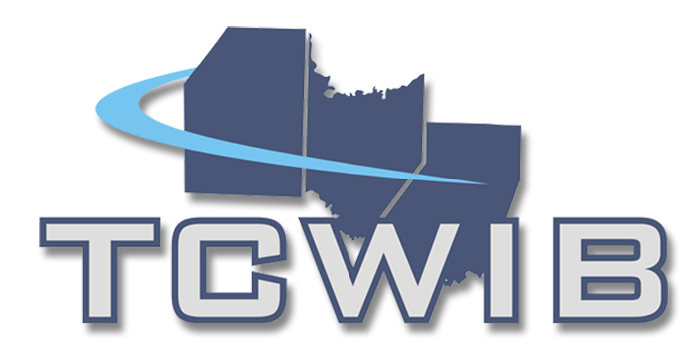
Tri-County Workforce Investment Board, Inc.
112 Hollywood Drive, Suite 201
Butler, PA 16001
Phone: 724.282.9341
Fax 724.282.4896
www.tricountywib.org

Previous Winners include:
ACMH Hospital
Butler Eagle
Butler Technologies, Inc.
Clark Metal Products
Cleveland-Cliffs Butler Works
Communities at Indian Haven
Community Guidance Center
Cygnus Manufacturing Company
Diamond Pharmacy Services
Dynamic Manufacturing LLC
Embassy of Hillsdale Park
FLIR Government Systems, Inc.
H&W Global Industries, Inc.
HAVIN, Inc.
HF Sinclair-Sonneborn
Indiana County Technology Center
Indiana Regional Medical Center
Kensington HPP, Inc.
LIFE-Butler County
Miller Fabrication Solutions
Oberg Industries
Penn United Technologies, Inc.
Progressive Workshop of Armstrong County
Projectile Tube Cleaning, Inc.
Quality Life Services
Renda Broadcasting Group
Reschini Group
S&T Bank
SinterMet LLC
Sloan Brothers Company
Township of Butler

The Tri-County Workforce Investment Board is seeking nominations for employers in Armstrong, Butler, and Indiana Counties who have significantly contributed to workforce development within the region.
An Employer of the Year Award will be given to an employer in each of the three counties to highlight the collaboration of business and workforce investment in the three counties.
The deadline for nominations is October 16, 2025.

Eligibility – Nominees must be an employer located in Armstrong, Butler, or Indiana Counties.

Nominations – Nominations will be accepted from anyone within the community. Employers are strongly encouraged to nominate themselves. Previous winners may be nominated; however, a company cannot win two years in a row.

Criteria – Winners will be selected based on nominee efforts to support and utilize local workforce development.

Judging – Nominations will be reviewed by a committee of members of the Tri-County Workforce Development Board.

Announcements – Employers will be honored at the December 12, 2025 Workforce Investment Board Meeting. Winners will be notified prior to the meeting by email and a follow-up letter.

Questions – Please contact Paul Weifenbaugh, Assistant Director at the Tri-County Workforce Investment Board, Inc. at pweifenbaugh@tricountywib.org.

Nomination Form – Can be found at www.tricountywib.org under News & Events



NOMINATION FORM FOR EMPLOYER OF THE YEAR
Tri-County Workforce Investment Board, Inc.
Nomination Deadline: October 16, 2025.
Part 1

Name of Employer Nominated ___________________________________________________

Address_____________________________________________________________________

City, State, Zip _______________________________________________________________

County_____________________________________________________________________

Contact Name & Title__________________________________________________________

Telephone______________________________ Email______________________________

Please complete this section only if the information is different from the Nominee information.

Nominated by________________________________________________________________

Address_____________________________________________________________________

City, State, Zip________________________________________________________________

Contact Name & Title___________________________________________________________

Telephone______________________________ Email______________________________

Part 2

Number of Employees 1-99_____ 100-299_____ 300+_____

What Industry Sector is the nominee a part of?

Advanced Manufacturing _____
Agriculture/Food Processing _____
Biomedical _____
Building & Construction _____
Education _____
Energy _____
Health Care _____
Hospitality, Leisure & Entertainment _____
Logistics & Transportation _____
Real Estate, Finance & Insurance _____
Technology _____
Wood, Wood Products & Publishing _____
Other ______________________________

Areas of Workforce Development (Check all that apply.)

- Support for Industry Partnerships
- Worker Training
- Employee Recruitment/Retention
- Youth Pipeline Development/Business Education Partnership
- Utilization of PA CareerLink® Services
- Supports Veteran Programs
- Apprenticeships
- Youth Program Worksite
- Utilization of On-the-Job Training Program
- Other _____________________________

Part 3
Describe how the nominee engaged the workforce system areas checked above and utilized it for their business and/or industry. Tell us how the collaboration helped employees or potential workers and the business. How does the company promote workforce development within its organization and the community? Each of the areas checked above should be addressed in the essay. Attach additional pages as needed.

Provide any additional information or comments you wish to offer in support of this nomination. Attach additional pages as needed.

Please return all nomination forms to Paul Weifenbaugh, Assistant Director, Tri-County Workforce Investment Board, Inc., 112 Hollywood Drive, Suite 201, Butler, PA 16001, Fax: 724.282.4896, pweifenbaugh@tricountywib.org by October 16, 2025.

Caption goes here

DELETE BOX, OR PLACE LOGO HERE

